4. List the plan number, line number, resource name, number of resources (*eventplanline.number*), location name, time start, and time end where the event is held at the basketball arena, the event plan has activity of activity of “Operation”, and the event plan has a work date in the period October 1 to December 31, 2013. Your query must not use the facility number (“F101”) of the basketball arena in the WHERE clause. Instead, you should use a condition on the *FacName* column for the value of “Basketball arena”. 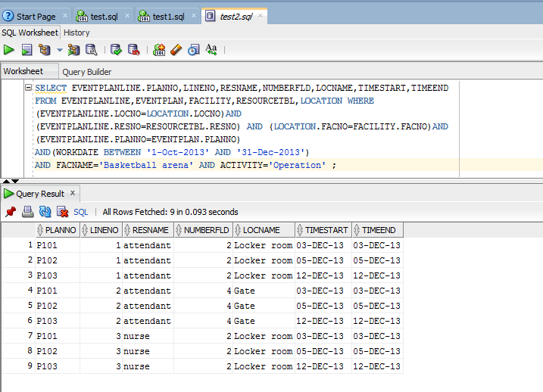

SELECT EVENTPLANLINE.PLANNO,LINENO,RESNAME,NUMBERFLD,LOCNAME,TIMESTART,

TIMEEND

FROM EVENTPLANLINE,EVENTPLAN,FACILITY,RESOURCETBL,LOCATION WHERE

(EVENTPLANLINE.LOCNO=LOCATION.LOCNO)AND

(EVENTPLANLINE.RESNO=RESOURCETBL.RESNO) AND (LOCATION.FACNO=FACILITY.FACNO)AND

(EVENTPLANLINE.PLANNO=EVENTPLAN.PLANNO)

AND(WORKDATE BETWEEN '1-Oct-2013' AND '31-Dec-2013')

AND FACNAME='Basketball arena' AND ACTIVITY='Operation' ;